Red Hat JBoss BRMS
Weight Watcher Demo
(Use case: stateless CEP decision service)

Stefano Picozzi
ANZ OpenShift SME
Sydney, Australia
spicozzi@redhat.com

Table of Contents
1Introduction 3
2Setup and Configuration 3
2.1Installation 3
2.2Basic JBoss BRMS Decision Server Configuration 5
2.3Advanced JBoss BRMS Workbench Configuration 8
3Running the Demo 14
3.1Basic Decision Server 14
3.2Advanced Workbench 15

Introduction
Interested in a demo that showcases the JBoss BRMS 6.1 Realtime Decision Server? Then look here. The application is a stateless Decision Server with complex event processing (CEP) support based on a pseudo clock.

An example use case demonstrated includes a (REST) client sending a time series of facts in the form of weight observations to the Decision Server. The Decision Server then reasons over the inputs to derive CEP insights such as average weight, least weight and weight change of a rolling time window. These insights are returned to the calling client as facts.
This is a facts-in-facts-out (FIFO) pattern using a standardized fact interface representation. This technique makes it easier for a simple thin client application such as SoapUI to send request/response payloads to the Decision Server without knowledge of the underlying rules data model.

http://blog.emergitect.com/2014/12/08/really-simple-rules-service/

Setup and Configuration

Installation
You first need to get the project by cloning it from the central location:

$ git clone git://github.com/StefanoPicozzi/weightwatcher.git

Once downloaded, you will have the following folder structure:
- \weightwatcher
  - \installs – Initially empty, but will contain the EAP, BRMS platform downloads.
  - \support – Additional supporting files used by the demo.
  - \target – Will be created by running init.sh. Contains the fully configured BRMS runtime server.
  - \docs – Contains quickstart guide you are reading and architectural overview slides.
  - init.{sh} – Script to install and configure the run time server environment.
  - Dockerfile – Script to build a Docker image
  - \test – SoapUI project file with test invocations
  - \src – source code including data model, rules and project settings

Then download and install SoapUI on your workstation from http://www.soapui.org/ .
Next, download JBoss BPM Suite from the Red Hat Customer Portal (https://access.redhat.com).
Download JBoss BRMS:
- Under JBoss Enterprise Platforms, select the BRMS product.
- Select version 6.1.0 in the Version field.
- Download Red Hat JBoss BMRS 6.1.0 installer

Now copy jboss-brms-6.1.0.GA-installer.jar, to the projects installs folder. Ensure that this file is executable by running:

$ chmod +x <path-to-project>/installs/ jboss-brms-6.1.0.GA-installer.jar

Download JBoss EAP 6.4:
- Under JBoss Enterprise Platforms, select the EAP product.
- Select version 6.4 in the Version field.
- Download Red Hat JBoss eap 6.4 installer

Now copy jboss-EAP-6.4.0-installer.jar, to the projects installs folder. Ensure that this file is executable by running:

$ chmod +x <path-to-project>/installs/ jboss-EAP-6.4.0.-installer.jar

Lastly, from the project folder, run the init.sh script for the traditional deployment option:

$ ./init.sh

When the script completes you will have a new folder named jboss-eap-6.4, in the target folder. The folder is a ready to run EAP 6 server with Jboss BRMS. Launch an instance of your new BRSM application:

$ ./target/jboss-eap-6.4.0/bin/standalone.sh

Basic JBoss BRMS Decision Server Configuration

Configuration consists of registering a Decision Server (kie-server) instance and then adding a container using the Decision Server management API. Server registration is currently a once-off manual step via the BRMS workbench GUI. Note that once an API is located, this step will be automated thereby enabling a fully automated demo.

To register the Decision Server instance, start the JBoss BRMS instance by running the standalone.sh script located under the /target directory. Then login to the workbench console using credentials for user spicozzi, password is jbossbrms1!

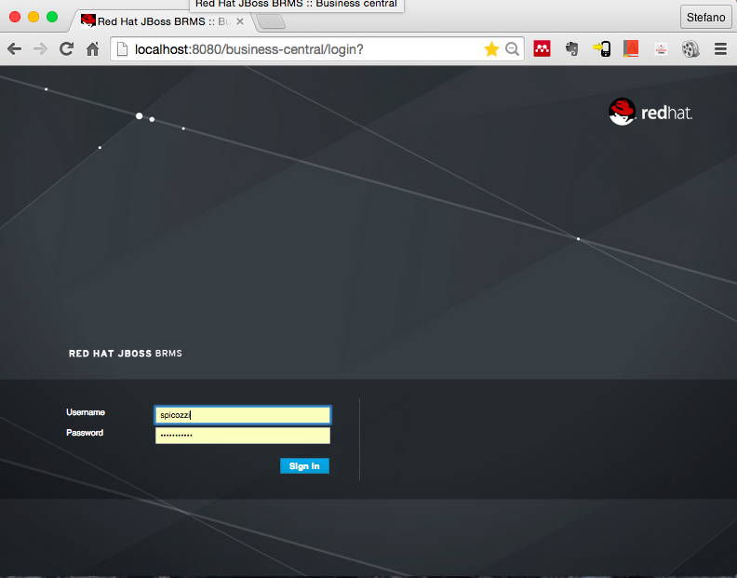

Create a Realtime Decision Server instance using the workbench. Choose Deploy from the menu and then click Register. Complete the form as follows:

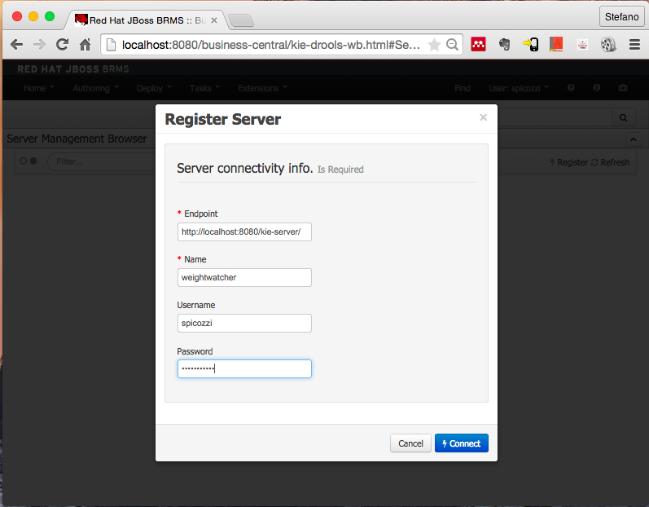

Next, create a container for your new Decision Server. To do this, launch the SoupUI client and choose the project located under /tests. Find and execute the Create Container REST/PUT invocation as per below.

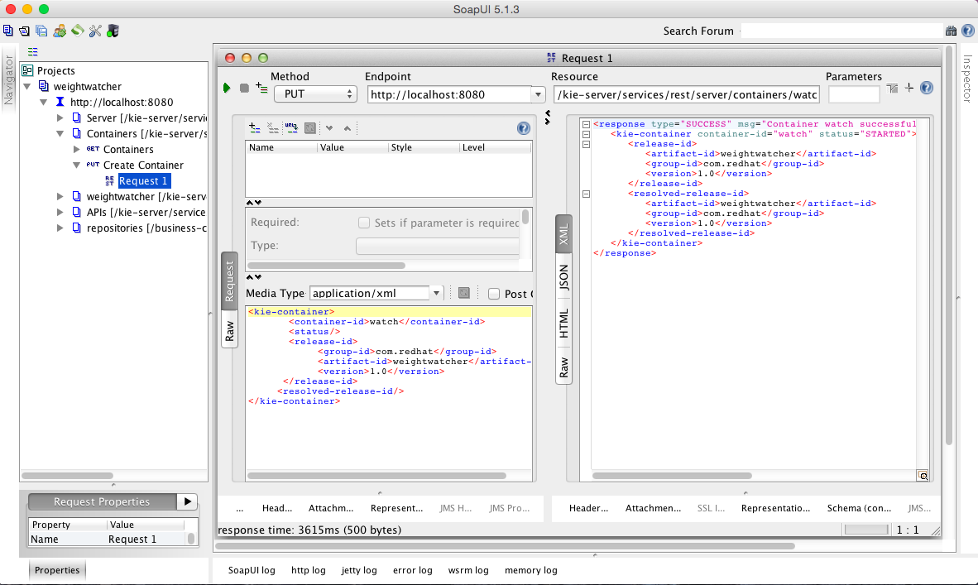

JBoss BRMS Workbench Configuration
You can also configure the BRMS workbench manually so that you can view and edit projects assets such as rules. To do this you need to create an organizational unit, repository and project and then use git to push in the source code, as follows.

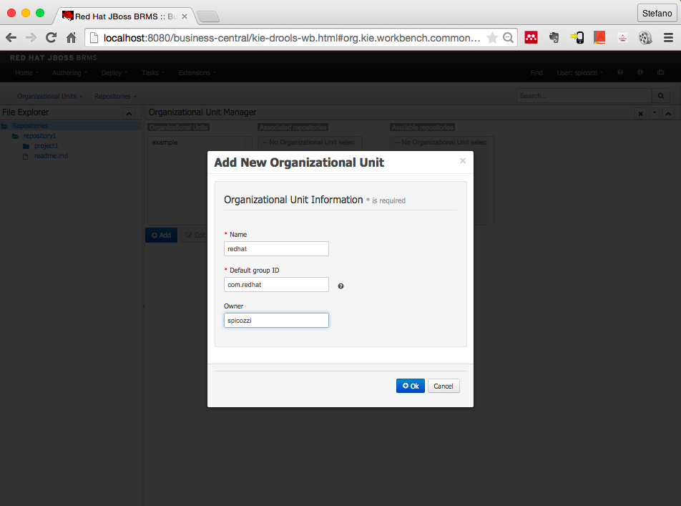

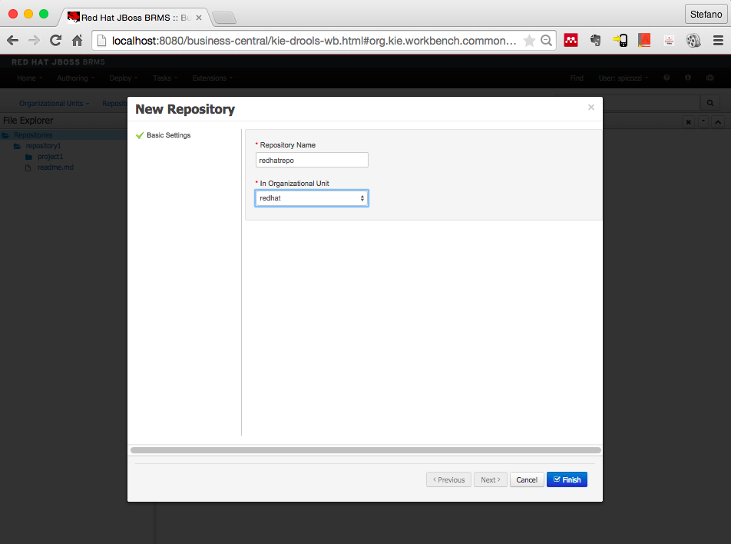

Ensure the redhat organizational unit and redatrepo are active in poject explorer and then create a project weightwatcher.

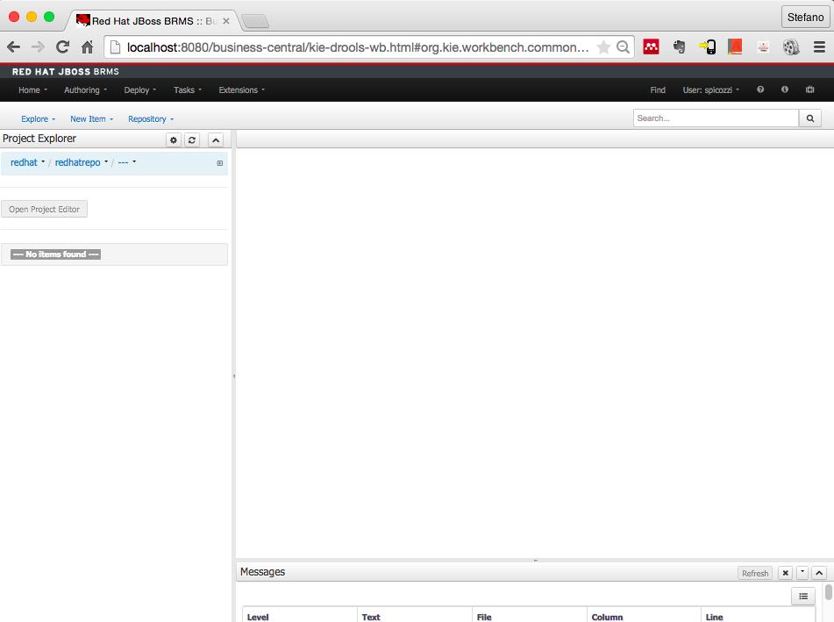

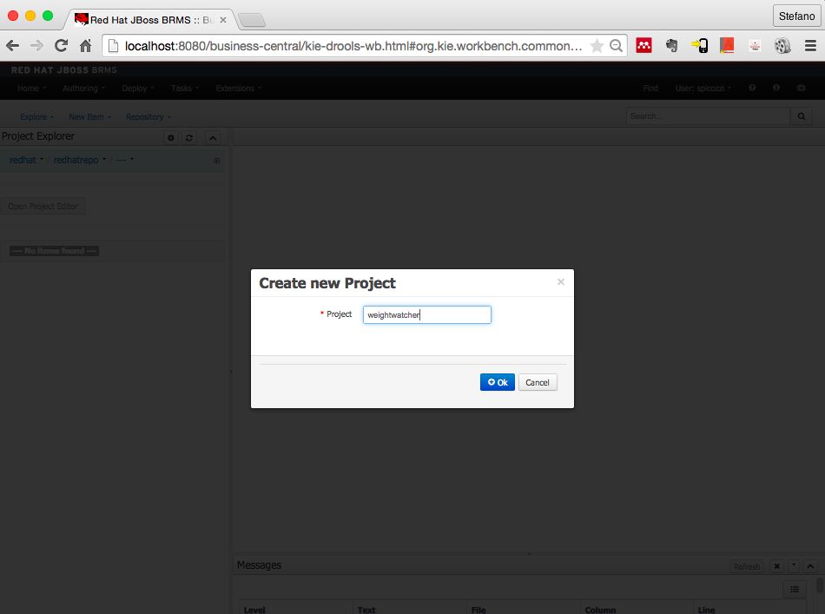
Now choose the Administration submenu under Author, and select the Repositories List. Click the ssh option alongside the redhatrepo item and copy the ssh link, which is likely to be ssh://localhost:8001/redhatrepo

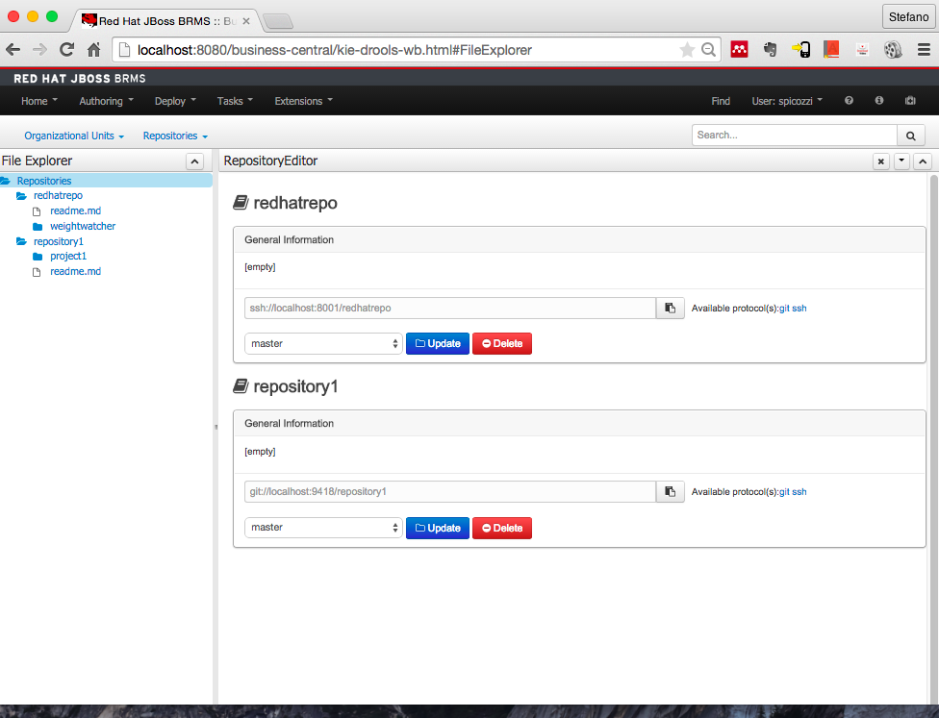
From the command line issue return to your demo installation location and replace the cloned empty src tree as follows:

$ cd \weightwatcher
$ git clone ssh://spicozzi@localhost:8001/redhatrepo
$ cd redhatrepo
$ cd weighwatcher
$ cp -r ../../src .
$ git add src
$ git commit -am “Replaced src”
$ git push

The populated project should now appear as follows in the workbench.

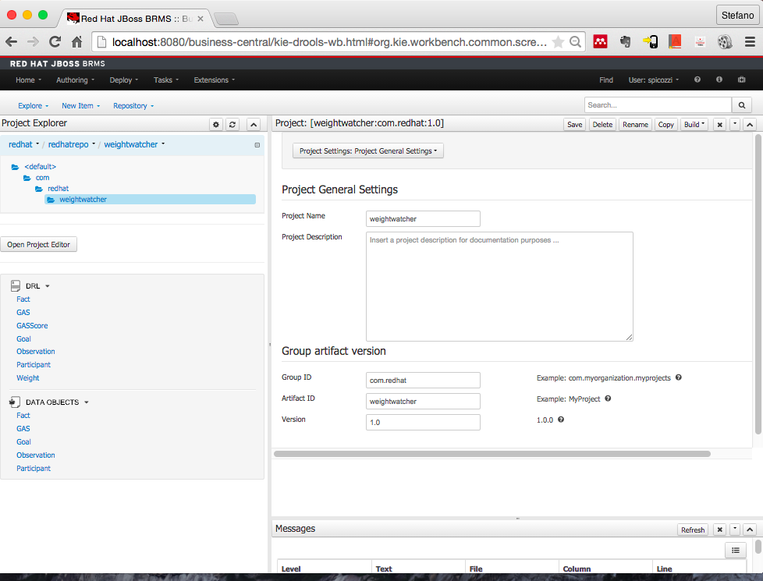

Complete Configuration
A complete and automate-able configuration approach consists of executing a few pre-supplied REST API calls from the SoapUI client and updating the git repository with the latest project source code.
Note that one manual BRMS Workbench step using the GUI is temporarily required due to an issue with the Create Repository Knowledge Management API.
First launch the SoapUI and then import the project located under /test. First run through the REST invocations numbered 01.

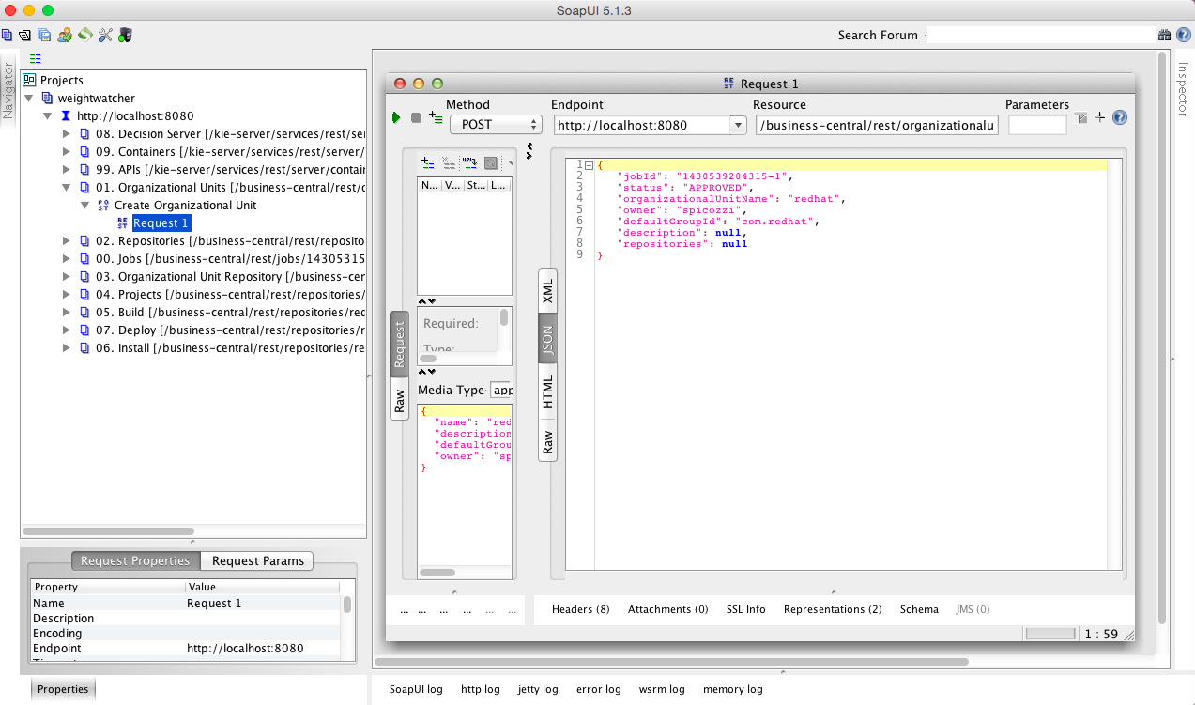

Then login to the Workbench and create a repository named redhatrepo.

Now return to the SoapUI client and run through the REST invocations number 03 to 07.

Then from the command line issue return to your demo installation location and replace the cloned empty src tree as follows:

$ cd \weightwatcher
$ git clone ssh://spicozzi@localhost:8001/redhatrepo
$ cd redhatrepo
$ cd weighwatcher
$ cp -r ../../src .
$ git add src
$ git commit -am “Replaced src”
$ git push

Now return to the SoapUI client and run through the REST invocations numbered 09.
Configuration is now complete and you may begin demonstrating business use cases as described in Section 3.

Running the Demo

Basic Decision Server
This demo shows a stateless request/response interaction with the Realtime Decision Server. Sample invocations are provided for your exploration in the SoapUI project. For example, the screen shot below shows an invocation in which a set of facts containing weight measurements is sent to the Decision Server. CEP rules are then applied to derive insights as per the response payload.
If you wish to edit or create your own invocations simply follow the examples provided and edit the XML payload content appropriately.
If you wish to inspect the source, review the data model and/or customize the sample rules provided then you need to first follow the instructions described workbench advanced set-up section.

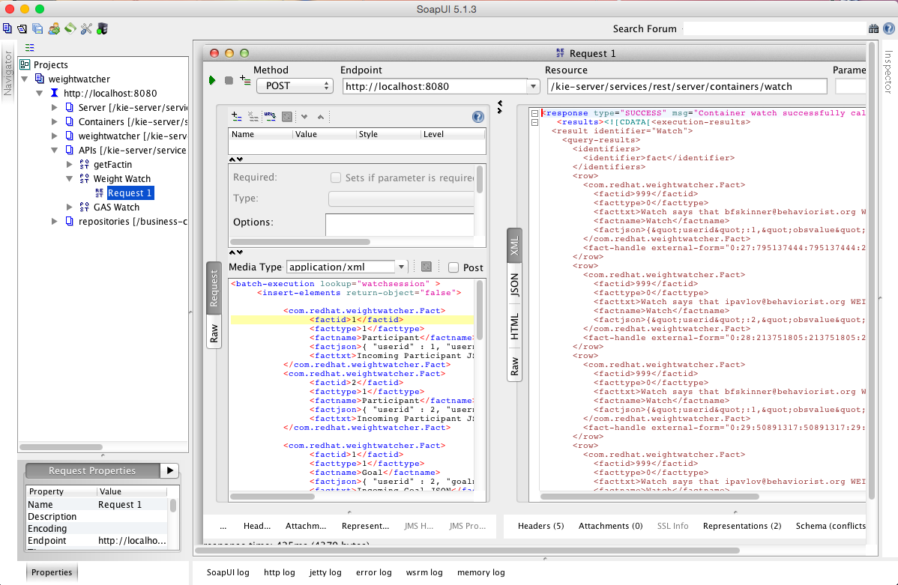

Advanced Workbench
If you performed the additional steps described in 2.3 to configure the workbench, you can also experiment with changing and creating rules and observing their impact. To do this, try the following from within the JBoss BRMS workbench:

- Select the Deploy menu and delete the watch container created previously
- Visit the weightwatcher project and edit the DRL named GASScore under the weightwatcher project
- Change the rule “ruleExpectedCount” so that it only counts when the Participant meets exactly his expected result (obsvalue == 0) and change the message accordingly by removing the “or better” text
- Rebuild the workbench project jar file
- Select the Deploy option again and recreate the watch container, you can also do this using the REST API instruction as in section 2.1
- Start the watch container
- Now return to the SoapUI client and invoke the GAS Watch API and confirm the changed rule behavior

The modified rule will look like:

rule "ruleExpectedCount"
salience -100
no-loop true
when
$participant : Participant( )
$gas : GAS( userid == $participant.userid )
$obscounttotal : Number( intValue > 0) from accumulate(
Observation( $obscount : obsvalue == 0, $participant.userid == userid, obsname == $gas.goalname ) over window:time( 60d ),
count( $obscount ) )
then
String rulename= new String( drools.getRule().getName( ) );
Integer userid = $participant.getUserid( );
String factname = new String( "Watch" );
String username = new String( $participant.getUsername( ) );
String facttxt = new String( "Weightwatcher says that for " + $gas.getGoalname( ) + ", " + username + " attained expected outcome " +
$obscounttotal + " times over the past 60 days" );
// Rest removed

